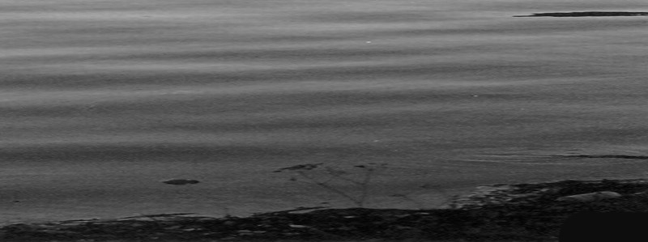
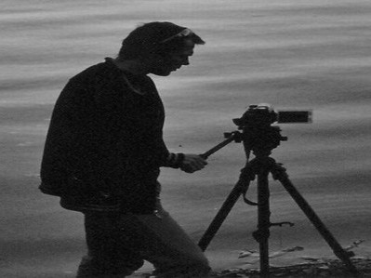
6. Mezinárodní festival outdoorových filmů ®
International Festival of Outdoor Films ®
2008
Česká repulika - Czech Republic

Pořadatel / Organizer: Cestovní kancelář Turistika a Hory, s.r.o., Smetanovo nám. 7, 702 00 Ostrava, Czech Republic

Tel./fax: +420 596 620 500, GSM: +420 603 871 937, email: info@mfof.cz, www.mfof.cz

The competition rules of INTERNATIONAL FESTIVAL OF OUTDOOR FILMS 2008 (IFOF)
(ADVENTUROUS, EXTREME AND MOUNTAIN FILMS)

Organiser of IFOF type out this condition for the year 2008

Preamble: people interested in the above stated sport area initiated establishing of this festival. Because our clients and big amount of our friends devot ourselves to these sport activities. According to experience from last year we decided not to make just an ordinery film festival in one town but touring festival, which starts in town Ostrava (the biggest town of the Moravian region). So that, all the films including awarded motion pictures can be watched in chosen towns in the Czech Republic. Our idea is to expand this film art not only in the Moravian region, which is not very known abroad but also into all parts of our country and the Slovak Republic.

1 ARTICLE - ATTENDANCE
The professionals as well as amateurs creators, film and TV producers from the Czech or Slovak Republic and also from abroad can take part in IFOF 2008.
The movie involved in our competition could have been presented at other festivals or competitions in previous years also in the year 2008 in the Czech Republic or abroad. The motion pictures presented in the year 2008 at other festivals can compete at our festival as well.

2 ARTICLE - ORGANIZER
IFOF 2008 is organised by sport and travel agency CK Turistika a Hory Ltd.
Address:

CK Turistika a Hory Ltd., Smetanovo nám. 7, Ostrava 1, 702 00, Czech republic, tel: +420/596 620 500, 603 871 937,

www.turistika–hory.cz, mail: info@turistika-hory.cz
Bank acount at Komerční banka Account number: 35-1739370207/0100

3. ARTICLE - PLACE AND TERM
IFOF is going to take a place during October - December 2008 in Ostrava and also in other chosen towns of the Czech Republic and the Slovak Republic.

4. ARTICLE - JURY AND COMMITTEE
A jury that is nominated by organizer will judge the registered films. The committee (named by organizer) will choose competitive films, which must fulfil given criterions of competition.
Committee competence: * the films which have more familiar character might be rejected; * rearrange the films into more appropriate categories; * cancel the category - in case of small quantity of films in the category

5. ARTICLE - CATEGORIES
Registered films will be divided into these categories:
A. Adventurous and extreme sport films - outdoor films except mountain climbing, which are: mountain bikes, skiing & extreme skiing, ski-alp, speleology, paragliding, parachuting, aviation, motor sports
B. Mountain climbing & mountain films – mountain climbing, rock climbing, ice climbing, mountain scenery, man & mountains
C. Adventurous water sport films – rafting, watercraft sports, yachting, canoeing, diving, long distance swimming, a man & water
D. Travel film – ( films of travel character which aren not in categories A,B,C)

6. ARTICLE - PRICES AND VALUATION WINNING FILMS
Jury could price the motion picture chosen into the competition:
1. Main prize of festival (without difference between the categories)
2. Festival award in each category
3. City award (without difference between the categories)
4. Viewers’ choice award (without difference between the categories)
5. Jury prizes (without difference between the categories)

Winners will be given lagniappe awards from sponsors and organizer of IFOF + reminder lists. Every participant of festival will be given reminder list, catalogue & report of festival and representative CD. The jury set aside the right not to give an award in any category in reasonable case.

Organizer undertake as follows:

● send the prizes to the winners into 2 months after the end of IFOF and all the

related showes in the CR

● publish the awarded films in selected sport and public medias in the CR

● inform general public about the festival and competition

● offer the winning motion pictures to TV company to be put on program

7. ARTICLE - ENTRY FORM & SENDING FILMS

Each film has to be written on one entry form. Please fill in entry form your postal address, phone number or email address. DVD (videotape, BETACAM, mini DVD...) with a film and entry form will be send to the following address:

Adress: CK Turistika a Hory Ltd., Smetanovo nám. 7, 702 00 Ostrava 1 Czech Republic, Europe

ALL THE FILMS MUST BE DELIVERED TO OSTRAVA BEFORE 18.7.2008
(The films could be sent to us immediately after receiving this application form.)

Let me draw your attention to this requirement:
The movie pictures should be in Czech, Slovak or English language. If they are not, they should have subtitles in mentioned language. Otherwise, the dialog concept with time plan in the original language must be attached. All the films will be shown in the original language with simultaneous translation for Czech viewers.
1. There need to be attached:
- a potted version of all sent films
- 2 photographs of the film (9x13cm minimally) – will be used for the catalogue
The above stated photographs and also the documents will be published free of charge and archived by organizer.
2. Received DVD, videotape, etc. must contain only one movie for registration. That means that each film need to be recorded on a separate tape or DVD. If the films are not on DVD or BETACAM, the VHS have to be high-quality copy.
3. The films send for competition purpose need to be sent on the tape/cassette:
- VHS
- S-VHS
- BETACAM
- DVD
Organizer guarantee giving the delivered copy back to author.
4. Organizer has the right to make copies of chosen films - for archive purpose only, promotion of following film festival, supporting events connected with IFOF, promotional presentation and presentation of Echo of festival.
5. Transport expenses (post costs) conjoint with sending the videotapes from author country to organizer address meet author.
6. Transport expenses (post costs) conjoint with sending the prices, promotional stuffs, souvenir and videotapes back to author meet organizer.

8. ARTICLE - COPYRIGHTS
1. The films’ authors provide to organizers of IFOF copyrights for public production at IFOF in Ostrava and also for projection in other chosen town in the Czech Republic and for propagation of festival, including ECHO - winning film show and agree with usage of film short cuts for MFOF invitation, which will be published in a cinemas, TVs and public actions.
2. Organizer guarantee not to use the received motion pictures for commercial purpose or for sale. This could be done only in case the organizer makes an agreement with author.
3. Organizer guarantee not to make any copy from the received films (except the cases mentioned in 7. article). Sent films will be used for competition and festival presentation.
4. Producers, authors of sent films undertake following:
  - To publish that the sent film was participated in IFOF 2008
  - was priced at IFOF 2008

9. ATTENDANCE APPROVAL
Full acceptance of all the articles and regulations (competition rules) is necessary for the attendance.

10. AUTHORS´ INVITATION TO IFOF 2008
All authors of competition films are invited to IFOF 2007 by the organizer. Acomodation for 1 day (in term of opening or proclamation of winning films IFOF 2008 in Ostrava) are defraied by the organizer for one author only.
Transport to Ostrava and board during the festival are not paid.
All the authors are obliged to inform the organizer in time about the date of arrival and term of accomodation.

Mgr. Jiří Kráčalík
The head of organizational committee

www.mfof.cz

